WeeRide OZ 2020
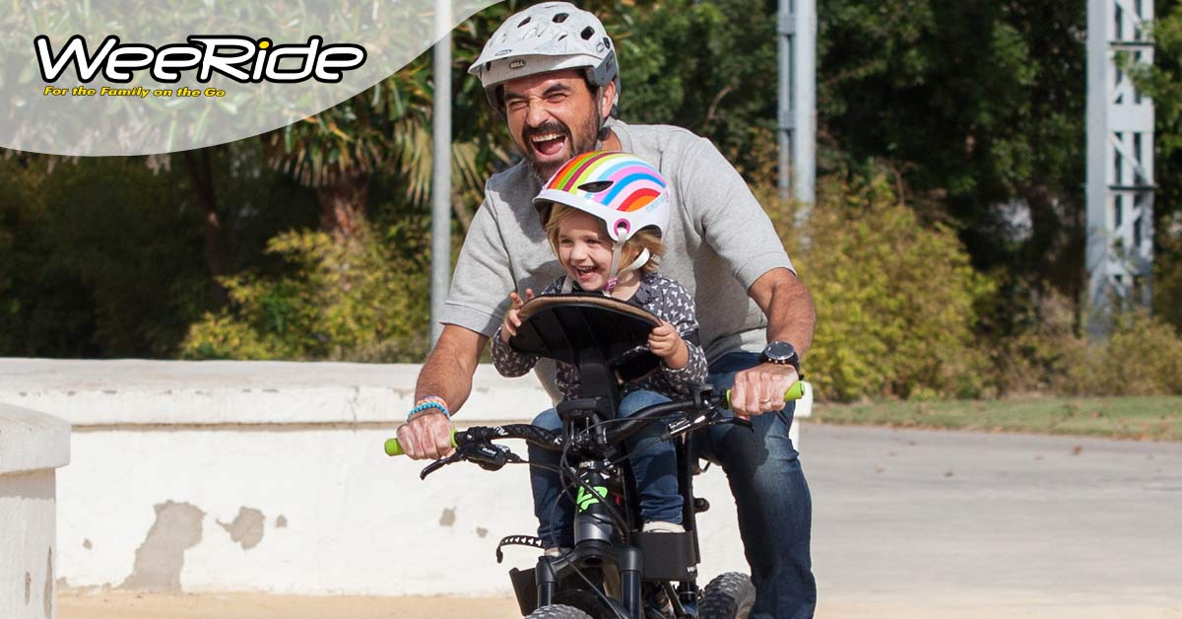

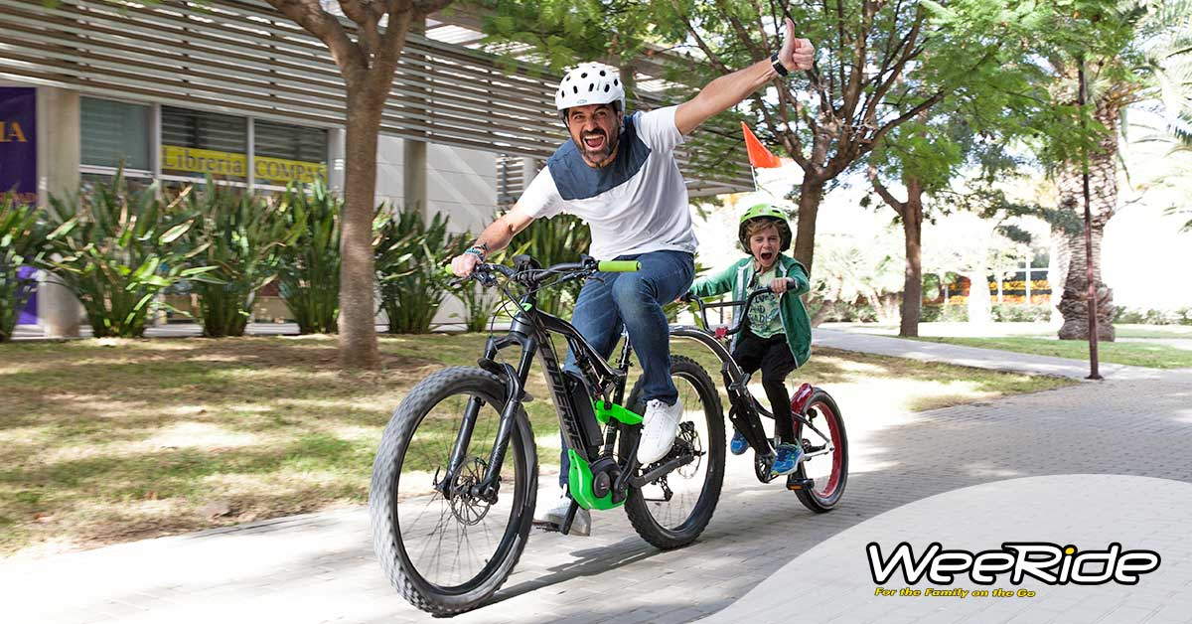


Child and Baby Bike Seats
WeeRide Classic Child Bike Seat
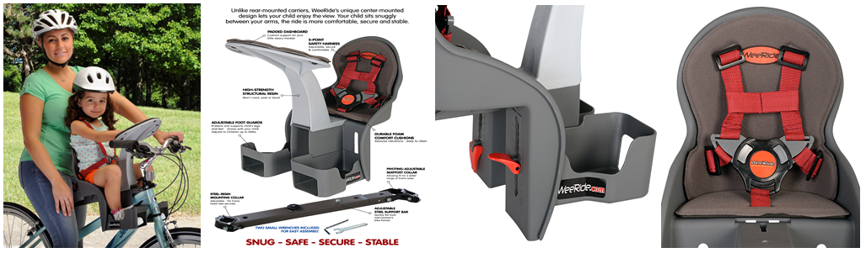
SUMMARY 98077
The WeeRide Classic is the original and best front mounted child seat. This is because it isn’t actually front mounted, but is centre mounted. Front mounted seats put all the child’s weight on the handlebars which means steering is more difficult, your child gets thrown around, and most importantly, are unsafe in our opinion if you need to stop quickly.
Our centre mounted seat puts all the weight centrally and your child is safely wrapped in your arms. The first time you ride the seat you realise why the reviews are so good as it is such fun being able to chat to your child and point things out.
KEY SALES POINTS
- A unique CENTRE MOUNTED bike seat for children
- Number 1 selling seat in the UK and US
- Recommended for ages from 1-4 years. Though can be used as soon as neck muscles are strong enough ie 6-9 months.
- Allows the rider to communicate with their child.
- Child’s needs can be dealt with.
- Interesting view for the child, not just your back!
- Patented bar puts weight in centre of bike and not on front like other front seats
- No attachment to the handlebars which we believe is dangerous
- You feel the child is more secure with your arms around them.
- The seat can be fitted easily within 20 minutes
- The seat can be removed in seconds for solo riding
- Headrest for baby to sleep, which they do at an early age
- No dangling legs as moveable footrests
- Fits all bikes including oversized head tubes and full suspension of 16”+ (except drop handle bars). Comes with its own bar so fits to Ladies and Mens bikes.
- 5 point safety strap and enclosed movable footrests for child safety
- Extra bars available for multi bike use
- Everything you need is in the box including the seat, bar and tools
WeeRide Deluxe Baby Bike Seat
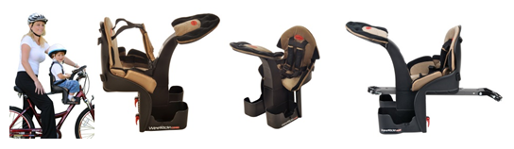
SUMMARY 98100
The WeeRide Deluxe is the original and best front mounted child seat. This is because it isn’t actually front mounted, but is centre mounted. Front mounted seats put all the child’s weight on the handlebars which means steering is more difficult, your child gets thrown around, and most importantly, are unsafe in our opinion if you need to stop quickly.
Our centre mounted seat puts all the weight centrally and your child is safely wrapped in your arms. The first time you ride the seat you realise why the reviews are so good as it is such fun being able to chat to your child and point things out. The Deluxe seat has all the features of the Classic seat, but adds the plusher cushioning on the seat and headrest. These seats tend to sell more to children under 18 months who may need the extra padding. The Classic seat is Business Class, the Deluxe is First.
KEY SALES POINTS
- A unique CENTRE MOUNTED bike seat for children
- Number 1 selling seat in the UK and US
- Recommended for ages from 1-4 years. Though can be used as soon as neck muscles are strong enough ie 6-9 months.
- Allows the rider to communicate with their child.
- Child’s needs can be dealt with.
- Interesting view for the child, not just your back!
- Patented bar puts weight in centre of bike and not on front like other front seats
- No attachment to the handlebars which we believe is dangerous
- You feel the child is more secure with your arms around them.
- The seat can be fitted easily within 20 minutes
- The seat can be removed in seconds for solo riding
- Headrest for baby to sleep, which they do at an early age
- No dangling legs as moveable footrests
- Fits all bikes including oversized head tubes and full suspension of 16”+ (except drop handle bars). Comes with its own bar so fits to Ladies and Mens bikes.
- 5 point safety strap and enclosed movable footrests for child safety
- Extra bars available for multi bike use
- Everything you need is in the box including the seat, bar and tools
- Deluxe seats adds extra thick seat and headrest padding
WeeRide Co Pilot Tagalong Trailer Bike
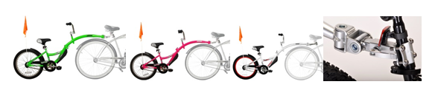
SUMMARY -86457 GREEN / 86459 PINK / 26459 SILVER
Why buy a tow bar and have all the connection problems and instability for your little one?
Tagalongs are perfect for children aged 4 to 9 who can’t manage those longer bike rides, or maybe haven’t mastered riding just yet. They can also be used for children with balance issues. Our tagalongs have all the safety and convenience features of the top brands, but at a lower price. The most important part of a tagalong is the pivot, and we have the best system, with the Sync Link Pivot.

KEY SALES POINTS
New patented Sync Link Pivot design ensures smooth movement and ride for child
Superior design Front Splash Guard
New arm folds easily for compact storage / movement
True quick release system for fast detachment from adult bike
Adjustable handlebars, up/down and rotation adjustments for maximum age range
Uniquely fits oversized seat posts, upto 40mm, and 700c wheels
Higher quality seat than most others
Beautiful paint finishes of silver or fluoro pink.
Safety Flag included
20" wheel size
Holds up to a 35kg rider
Recommended for ages 4 – 9, rider must have inside leg of at least 52cm to pedal at lowest, but can coast on pedals at 40cm
Child can pedal forward, backwards or coast

PRODUCT SPEC
CO PILOT TAG ALONG NEW SILVER | 26459 | 016751 2645928
CO PILOT TAG ALONG NEW GREEN | 86457 | 016751 8645700
CO PILOT TAG ALONG NEW PINK | 86459 | 016751 8645946

WeeRide Pro Pilot Tag Along Trail Bike
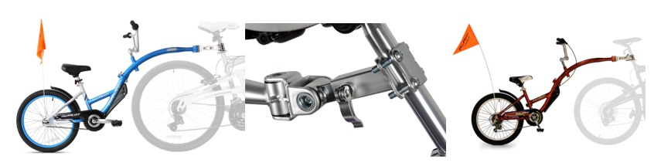
SUMMARY PRO 36999 / PRO 6 SPEED 96888
Why buy a tow bar and have all the connection problems and instability for your little one?
Tagalongs are perfect for children aged 4 to 9 who can’t manage those longer bike rides, or maybe haven’t mastered riding just yet. They can also be used for children with balance issues with the addition of an Adams backrest. The most important part of a tagalong is the pivot, and we have the best system, with the Sync Link Pivot. The Pro Pilot is our “deluxe” tagalong with a lightweight aluminium frame and beautiful blue finish. We also have a six speed version in the original red glaze.

KEY SALES POINTS
New patented Sync Link Pivot design ensures smooth movement and ride for child
Superior design Front Splash Guard
New arm folds easily for compact storage / movement
True quick release system for fast detachment from adult bike
Adjustable handlebars, up/down and rotation adjustments for maximum age range
Uniquely fits oversized seat posts, upto 40mm and 700c wheels
Higher quality seat than most others
Safety Flag included
20" wheel size
Holds up to a 35kg rider
Recommended for ages 4 – 9, rider must have inside leg of at least 52cm to pedal at lowest
No need for speeds, why complicate the issue and make it more expensive?
Child can pedal forward, backwards or coast
Aluminium no rust frame weighs approx. 10kgs
You need 2" beneath your seat to attach the bracket.
Includes two mudguards and chain guard
PRODUCT SPEC
ALLOY PRO PILOT TAG ALONG | 56888 | 016751 5688816
PRO WITH GEARS | 36999 | 016751 369990


WeeRide Kazam Link Tagalong Trailer Bike
THESE TAGALONGS CANNOT BE SOLD TO AMAZON DIRECTLY OR INDIRECTLY
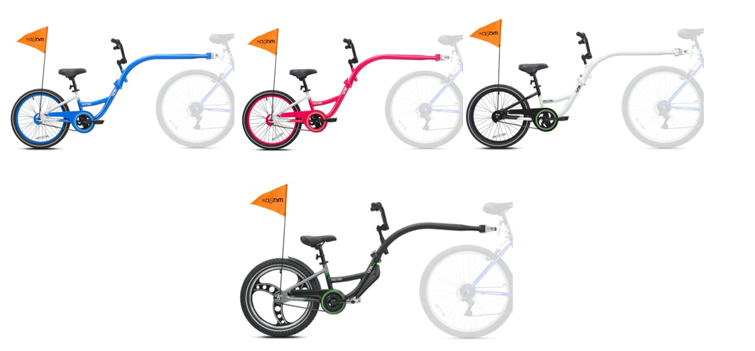
The Link range are the newest tagalongs from WeeRide and have a new frame shape along more clearance for larger wheel bikes or panniers.
They are very similar to the Co Pilots with similar sales points.
KEY SALES POINTS
New patented Sync Link Pivot design ensures smooth movement and ride for child
Superior design Front Splash Guard
New arm folds easily for compact storage / movement
True quick release system for fast detachment of your bike trailer from the adult bike
Adjustable handlebars, up/down and rotation adjustments for maximum age range
Uniquely fits oversized seat posts, upto 40mm, and 700c wheels
Higher quality child bike seat than most others
Beautiful paint finishes of silver, fluoro green or fluoro pink.
Safety Flag included
20" wheel size
Holds up to a 35kg rider
Recommended for ages 4 – 9, rider must have inside leg of at least 52cm to pedal at lowest, but can coast on pedals at 40cm
Child can pedal forward, backwards or coast
The Link Pro adds:
Aluminium Mag Wheels, Aluminium Frame and
Rear mudguard and crud guard
Extra wide 2.4 tyre
3 piece crank

Ibert Child Cycle Seat
49100 GREEN / 49101 PINK
Kent US recently bought out their major competitor in the US, Ibert.
The Ibert seat has been very popular in the US and has been seen out with famous faces like Tori Spelling and Pink:
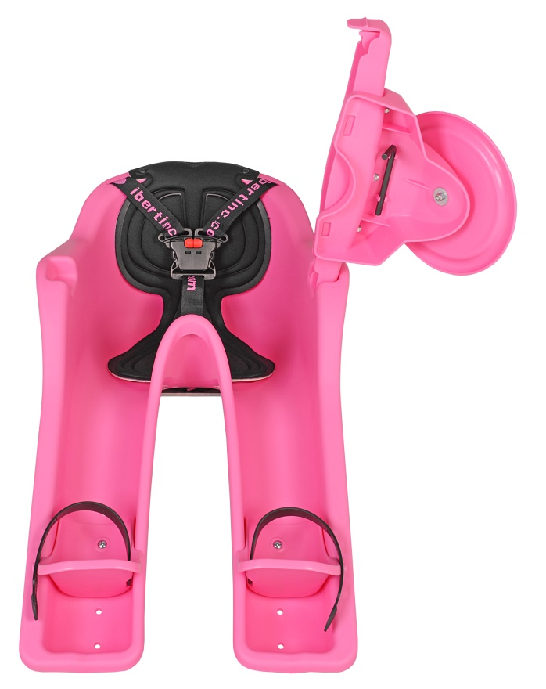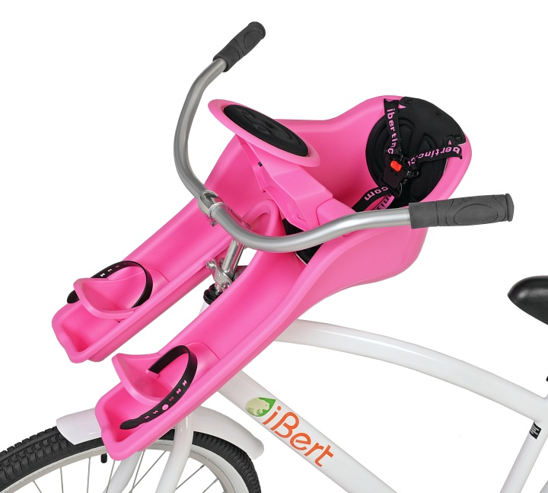

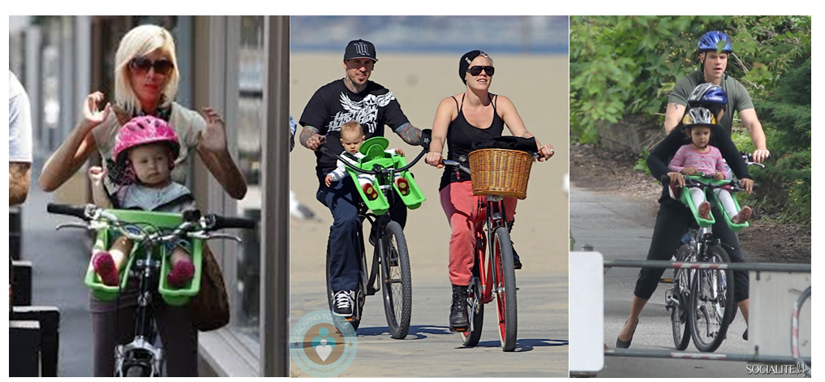

Bar can be attached to a bike in 2 minutes and seat can be attached and removed in a matter of seconds.
Great for ladies bikes as can dismount the front. Also ideal for Cruiser bikes.

Improvements we have made to the product:
Steering wheel now included, not an add on accessory
Connection PIN changed to remove wobble in seat.

2018 UPDATES: We will be MOVING PRODUCTION TO USA, and REDUCING THE PRICE. We will be marketing the fact the seat will be US produced and rebranding under KaZAM
Added footstraps.
New red seat being launched.

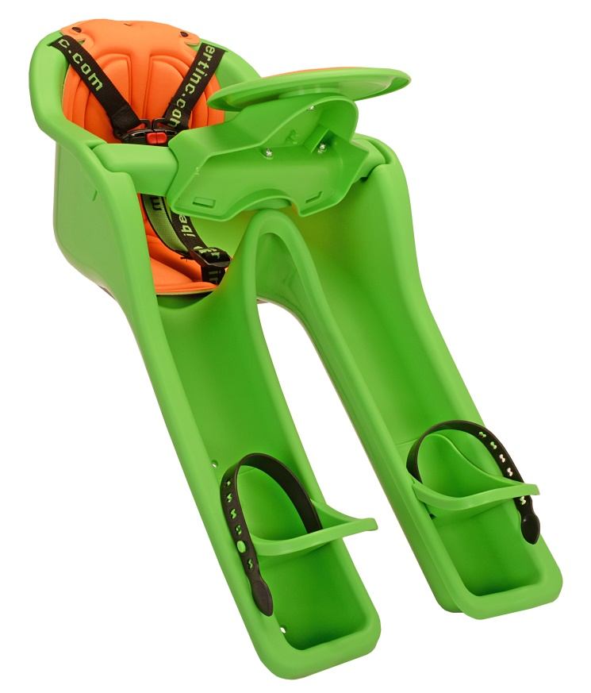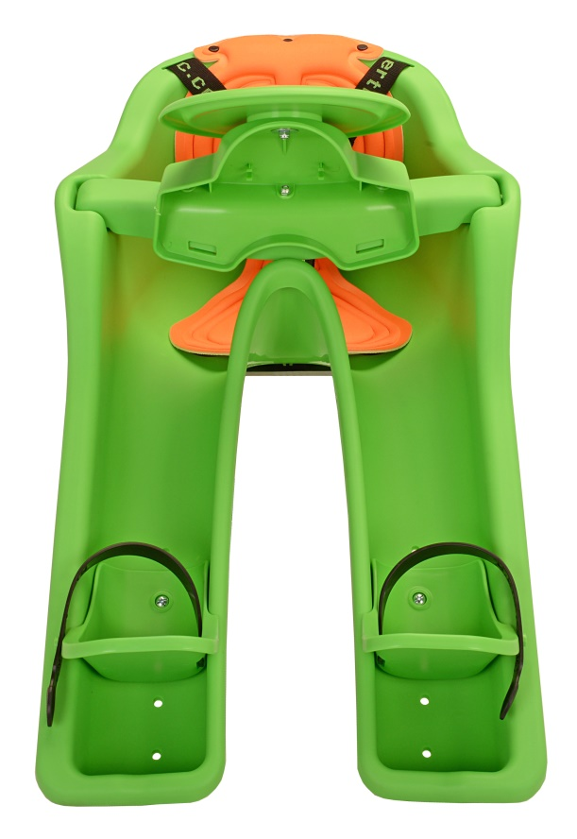

The iBert safe-T-seat provides families with exactly what they are looking for in a childrens bike seat; comfort, safety, an attractive and innovative design, and a good position where the child can fully explore the scenery. Nestled safely between your arms and behind the protection of the bicycle handlebars, your child can look around and be totally involved with the ride by turning the padded steering wheel.
- Center mount design provides a better center of gravity and increased mobility for the adult rider.
- Better view and more enjoyable ride for your child.
- Your child is safely positioned behind the handlebars which allows for better communication.
- Unlike trailers - no dirt, rocks or water get thrown into your child's face.
- Easier, safer loading and unloading of your little one

OTHER OFFERS FROM KAZAM…
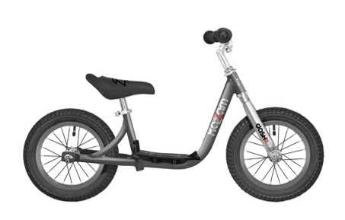12 INCH DASH 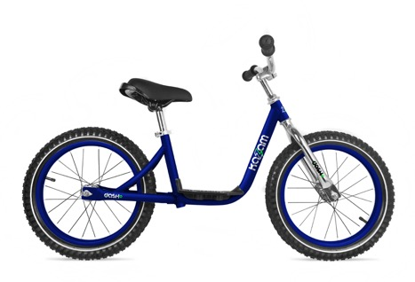16 INCH DASH
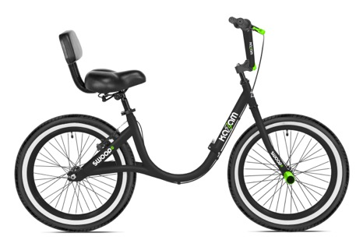20 INCH SWOOP
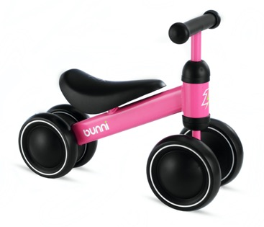BUNNI
Please let us know if you are interested in any of these products and we can provide more information.
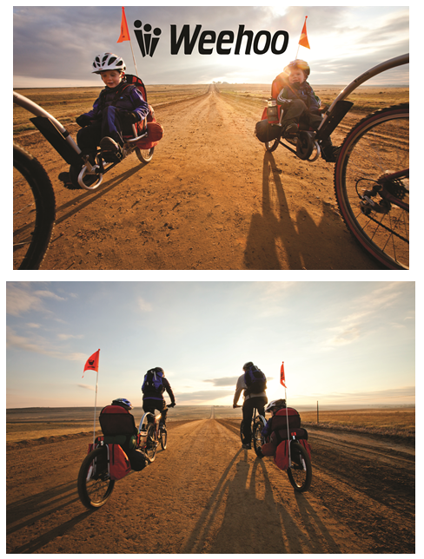
Weehoo was set up in 2010 by a bike enthusiast who didn’t like the tagalong and trailer options.
Stephen Rodgers is an ex pro mountain bike racer and has a degree in chemical engineering.
When his twins were very small he came up with the recumbent trailer and got the name from what his kids shouted when they first used it……Weeeeeeeehoooooooooo
Stephen’s technical background allowed him to hone the design of the tagalongs to be perfect for the child and rider. Weehoo’s attention to detail means the products are of the highest quality from parts down to paint finish. This is a company that does not see issues over quality. As an example all the parts are ziplocked to a cardboard tray inside the packaging to ensure no movement and simplicity of assembly.
Weehoo products are designed for Safety and Fun.
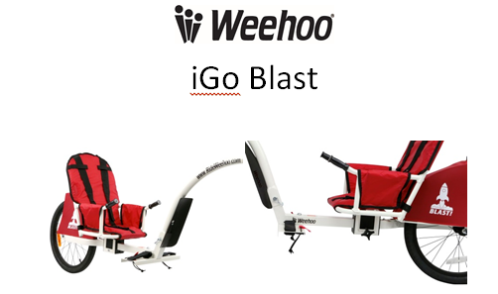
K3000 Weehoo iGo Blast Bike Trailer
The unique, active experience of Weehoo iGo bike trailer makes for meltdown-free rides. Finally, parents can take their children on their style of ride without stopping every five minutes to tend to bored, unhappy children.
The kids are happy, excited, while you’re making long lasting memories together. And most importantly they are safe in a quality built product.

Safe, engaging, and fun, the Weehoo Blast are the new benchmark in bicycle trailers. The balanced, streamlined design of the iGo gives you the ability to share your style of riding with your children. And riding is easy with the patented, self-aligning hitch, and single wheel design. The new, redesigned seat allows for tool free adjustments. The seat adjusts to accommodate kids 1 to 4 years old. The maximum per seat weight limit is 80 lbs. Keep little ones safe and secure by using the foot straps and the adjustable 3-point harness. Removable push bar easily detaches for travel and storage by removing the newly added snap pins.

This is the entry seat from the Weehoo range and allows your child to have all the fun of a tagalong at an earlier age.

KEY SALES POINTS
- Suits ages 1 , 2 , 3 , 4 years
- Max weight of child is 80lbs in trailer
- Quick adjustable baby child bike seat
- Patented self-aligning tagalong trailer alloy hitch
- 3 point safety harness and safety flag
- Front tag a long mudguard
- Padded baby child bike seat for comfort
- Option to cover with all weather canopy
- Heal bungee for foot security
- Latest model includes more rear wheel clearance and stability
- Superb paint finish
- 20 inch wheel
- Aluminium rims
- Forged alloy hitch
- Fits all bikes except – carbon seatposts, non cylindrical seatposts and some droppers

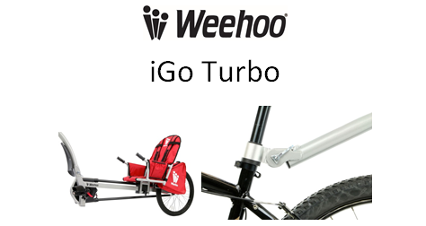
K1000 Weehoo iGo Turbo Cycle Trailer
The new, redesigned seat allows for tool free adjustments. The seat adjusts to accommodate kids 2 to 9 years old. For either IGO Turbo model, the maximum per seat weight limit is 80 lbs. Maximum total weight limit for the single seat iGo, iGo Venture, and iGo Two trailers with cargo and passenger(s) is 80 lbs. Keep little ones safe and secure by using the foot straps and the adjustable 3-point harness with chest buckle. The foot straps are redesigned for 2017 as well and make set up that much easier. Removable push bar easily detaches for travel and storage by removing the newly added snap pins. There is lots of storage provided in the seat and in the panniers on both sides of the rear wheel. The sprocket and chain are enclosed to keep little fingers grease free and away from harm. The comfortable handgrips give children something to hold on to. Optional canopy and rain cover accessories are sold separately.
The Turbo is Weehoo’s flagship model. It is the prefect product for a child who is getting too big for a child seat, but not confident enough to go on to a tagalong. Or a child who has balance issues.
KEY SALES POINTS
- Suitable for kids 2-9 years old
- Max weight of 80lbs
- Kids can join the fun and pedal, or just sit back and relax
- Chain covered for extra safety for kids. Also allows you to hear if they are helping!
- Quick adjustable seat
- Patented self-aligning hitch
- 3 point safety harness and safety flag
- Front mudguard
- Padded seat for comfort
- Option to cover with weather cover
- Aluminium rims
- Forged alloy hitch
- Fits all bikes except – carbon seat posts, non-cylindrical seat posts and some droppers
- Heal bungee for foot security
- Latest model includes more rear wheel clearance and stability
- 8 Litres of storage
- Approximately 48”x14”x32” without push bar, 82”x14”x32” with push bar, and 27lbs

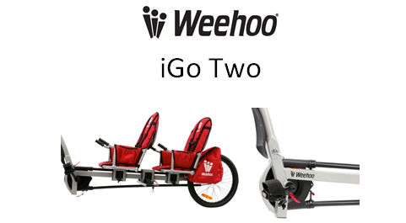
K1020 Weehoo iGo Two Recumbent Bike Trailer
With the iGo Two you can bring two children along for the ride. That is double the laughter and double the fun. All the benefits of the iGo but with two adjustable seats. The front passenger pedals and the rear passenger has their feet secured to a comfortable foot rest.
The new, redesigned seat allows for tool free adjustments. The seat adjusts to accommodate kids 2 to 9 years old. The Maximum weight capacity for the iGo Two is 80lbs. This equates to 2 six year old children based on average stats, or 1 eleven year old. Keep little ones safe and secure by using the foot straps and the adjustable 3-point harness with chest buckle. The foot straps are redesigned for 2017 as well and make set up that much easier. Removable push bar easily detaches for travel and storage by removing the newly added snap pins. There is lots of storage provided in the seat and in the panniers on both sides of the rear wheel. The sprocket and chain are enclosed to keep little fingers grease free and away from harm. The comfortable handgrips give children something to hold on to. Optional canopy and rain cover accessories are sold separately.
KEY SALES POINTS
- Suitable for kids 2-9 years old
- Max weight of 80lbs
- Kids can join the fun and pedal, or just sit back and relax
- Chain covered for extra safety for kids. Also allows you to hear if they are helping!
- Quick adjustable seat
- Patented self-aligning hitch
- 3 point safety harness and safety flag
- Front mudguard
- Padded seats for comfort
- Option to cover with weather cover
- Aluminium rims
- Forged alloy hitch
- Fits all bikes except – carbon seat posts, non-cylindrical seat posts and some droppers
- Heal bungee for foot security
- Latest model includes more rear wheel clearance and stability
- Approximately 60”x14”x32” without push bar, 94”x14”x32” with push bar, and 40lbs

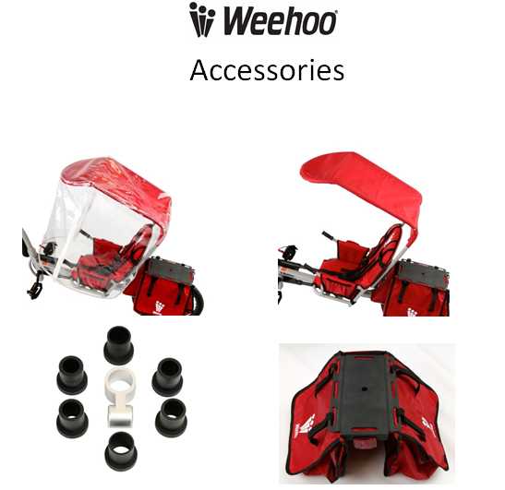
Weehoo Bike Trailer Accessories
Weehoo Hitch Kit K2000 - The extra hitch kit for 2015 Weehoo pedal trailers provides you the convenience of riding with the Weehoo iGo on several bicycles without having to remove and reinstall the hitch. Keep the extra hitch installed on a second bike and you’re ready to ride. (Not interchangeable with 2011 and iGo Pro trailers).

Weehoo All Weather Canopy K2030 – if you want your child protected from the rain or just the wind.

Weehoo Venture Pannies - Do you need to carry more stuff? The Venture Rack and Panniers can be added to any 2015 and beyond trailer. The panniers boast 20 liters of cargo space ( trailer not included).

