WeeRide UK 2020

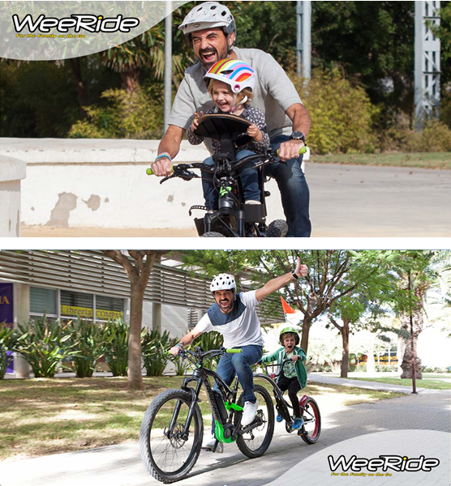



WeeRide Safe Front Child Bike Seat 98072E

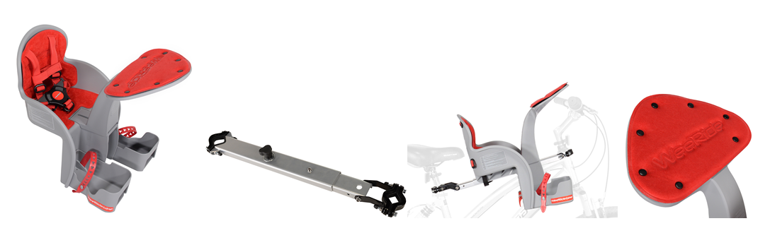
SUMMARY
The new, best selling WeeRide Safest Front Baby Bike Seat is our latest and best kids bike seat for children aged 1 to 4 years. This is because it isn’t actually a front mounted child seat, but is a centre mounted child seat. Front mounted seats put all the child’s weight on the handlebars which means steering is more difficult, your child gets thrown around, and most importantly, are unsafe in our opinion if you need to stop quickly. Our centre mounted seat puts all the weight centrally and your child is safely wrapped in your arms. This means you can use a WeeRide baby seat earlier than any other child seat on your bike. The first time you use the seat you realise why the reviews are so good as it is such fun being able to chat to your child and point things out. The differences between the Safe Front seats and the previous models are:
- Higher sides on baby bike seat for increased child stability
- Added strap underneath the bar for extra stability
- 2 movement thumbscrew for safety
- 2 movement buckle release for safety
- Additional straps on footcup holders
- Increased seat size
- New styling and colours
- Oversized buckle
- Open footcups for larger feet
- Now tested by TUV and GS to EN14344 European Safety Standards
KEY SALES POINTS
- The best selling baby bike seat in the UK and USA
- Patented centre mount baby cycle seat not front mount fixing system
- Recommended for ages from 1, 2, 3, 4 years. Though can be used as soon as neck muscles are strong enough ie 6-9 months.
- Allows the rider to communicate with their child.
- Child’s needs can be dealt with.
- Interesting view for the child, not just your back!
- Patented bar puts weight in centre of bike and not on front like other front seats
- No attachment to the handlebars which we believe is dangerous
- You feel the child is more secure with your arms around them in their bicycle seat.
- The seat can be fitted easily within 20 minutes
- The seat can be removed in seconds for solo riding
- Headrest for baby to sleep, which they do at an early age
- No dangling legs as moveable footrests
- Fits all bikes including oversized head tubes and full suspension of 16”+ (except drop handle bars). Comes with its own bar so fits to Ladies and Mens bikes.
- 5 point safety strap and enclosed movable footrests for child safety
WeeRide Safe Front Deluxe Baby Bike Seat 98102E
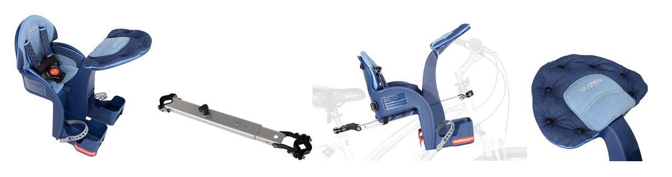
SUMMARY
The WeeRide Safe Front Deluxe is the top of our range. The new, best selling WeeRide Safest Front Baby Bike Seat is our latest and best kids bike seat for children aged 1 to 4 years. This is because it isn’t actually a front mounted child seat, but is a centre mounted child seat. Front mounted seats put all the child’s weight on the handlebars which means steering is more difficult, your child gets thrown around, and most importantly, are unsafe in our opinion if you need to stop quickly. Our centre mounted seat puts all the weight centrally and your child is safely wrapped in your arms. This means you can use a WeeRide baby seat earlier than any other child seat on your bike. The first time you use the seat you realise why the reviews are so good as it is such fun being able to chat to your child and point things out. The differences between the Safe Front seats and the previous models are:
- Higher sides on baby bike seat for increased child stability
- Added strap underneath the bar for extra stability
- 2 movement thumbscrew for safety
- 2 movement buckle release for safety
- Additional straps on footcup holders
- Increased seat size
- New styling and colours
- Oversized buckle
- Open footcups for larger feet
- Now tested by TUV and GS to EN14344 European Safety Standards
KEY SALES POINTS
- The best selling baby bike seat in the UK and USA
- Patented centre mount baby cycle seat not front mount fixing system
- Recommended for ages from 1, 2, 3, 4 years. Though can be used as soon as neck muscles are strong enough ie 6-9 months.
- Allows the rider to communicate with their child.
- Child’s needs can be dealt with.
- Interesting view for the child, not just your back!
- Patented bar puts weight in centre of bike and not on front like other front seats
- No attachment to the handlebars which we believe is dangerous
- You feel the child is more secure with your arms around them in their bicycle seat.
- The seat can be fitted easily within 20 minutes
- The seat can be removed in seconds for solo riding
- Headrest for baby to sleep, which they do at an early age
- No dangling legs as moveable footrests
- Fits all bikes including oversized head tubes and full suspension of 16”+ (except drop handle bars). Comes with its own bar so fits to Ladies and Mens bikes.
- 5 point safety strap and enclosed movable footrests for child safety

WeeRide Co Pilot Tagalong Trailer Bike
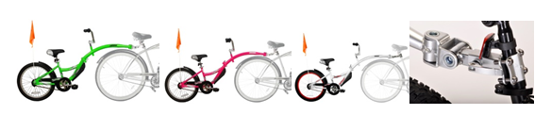
SUMMARY
WeeRide tagalong bike trailer for kids are the best design available.
Why buy a cycle tow bar and have all the connection problems and instability for your little one?
Tagalongs are perfect for children aged 4 to 9 who have outgrown their baby bike seat, but can’t manage those longer bike rides, or maybe haven’t mastered riding just yet. They can also be used for children with balance issues. Our tag a longs have all the safety and convenience features of the top brands, but at a lower price. The most important part of a tag along is the pivot, and we have the best system, with the Sync Link Pivot.

KEY SALES POINTS
New patented Sync Link Pivot design ensures smooth movement and ride for child
Superior design Front Splash Guard
New arm folds easily for compact storage / movement
True quick release system for fast detachment of your bike trailer from the adult bike
Adjustable handlebars, up/down and rotation adjustments for maximum age range
Uniquely fits oversized seat posts, upto 40mm, and 700c wheels
Higher quality child bike seat than most others
Beautiful paint finishes of silver, fluoro green or fluoro pink.
Safety Flag included
20" wheel size
Holds up to a 35kg rider
Recommended for ages 4 – 9, rider must have inside leg of at least 52cm to pedal at lowest, but can coast on pedals at 40cm
Child can pedal forward, backwards or coast

PRODUCT SPEC
CO PILOT TAG ALONG NEW WHITE | 86455 | 016751 864556
CO PILOT TAG ALONG NEW GREEN | 86457 | 016751 8645700
CO PILOT TAG ALONG NEW PINK | 86459 | 016751 8645946

WeeRide Pro Pilot Tag Along Trail Bike
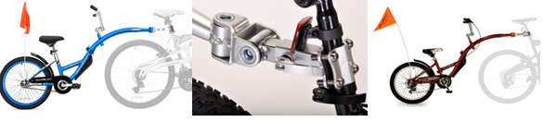
SUMMARY
WeeRide tagalong bike trailer for kids are the best design available.
Why buy a cycle tow bar and have all the connection problems and instability for your little one?
Tagalongs are perfect for children aged 4 to 9 who have outgrown their baby bike seat, but can’t manage those longer bike rides, or maybe haven’t mastered riding just yet. They can also be used for children with balance issues. Our tag a longs have all the safety and convenience features of the top brands, but at a lower price. The most important part of a tag along is the pivot, and we have the best system, with the Sync Link Pivot.
The Pro Pilot is our “deluxe” tagalong with a lightweight aluminium frame and beautiful blue finish. We also have a six speed version in the original red glaze.

KEY SALES POINTS
New patented Sync Link Pivot design ensures smooth movement and ride for child
Superior design Front Splash Guard
New arm folds easily for compact storage / movement
True quick release system for fast detachment from adult bike
Adjustable handlebars, up/down and rotation adjustments for maximum age range
Uniquely fits oversized seat posts, upto 40mm and 700c wheels
Higher quality seat than most others
Safety Flag included
20" wheel size
Holds up to a 35kg rider
Recommended for ages 4 – 9, rider must have inside leg of at least 52cm to pedal at lowest
Child can pedal forward, backwards or coast
Aluminium no rust frame weighs approx. 10kgs
You need 2" beneath your seat to attach the bracket.
Includes two mudguards and chain guard
PRODUCT SPEC
ALLOY PRO PILOT TAG ALONG | 56888 | 016751 5688816
PRO WITH GEARS | 96888 | 016751 9688898

WeeRide Kazam Link Tagalong Trailer Bike
THESE TAGALONGS CANNOT BE SOLD TO AMAZON DIRECTLY OR INDIRECTLY
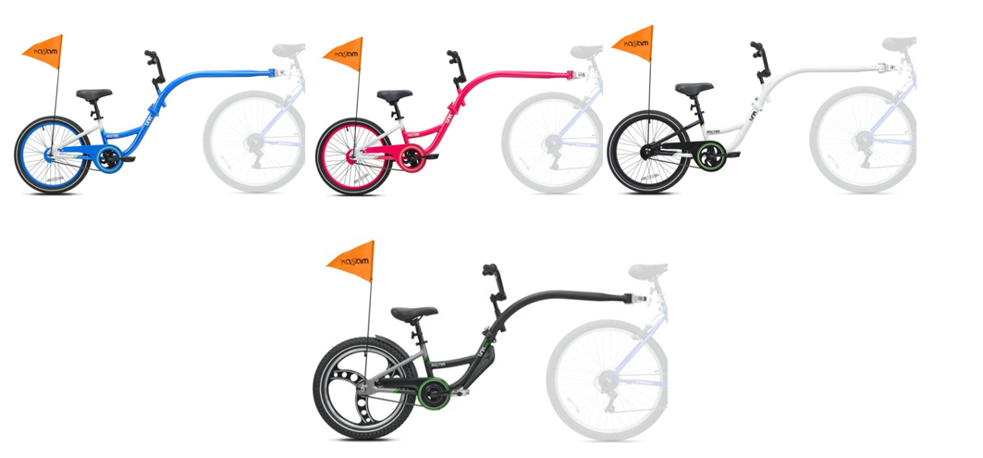
The Link range are the newest tagalongs from WeeRide and have a new frame shape along more clearance for larger wheel bikes or panniers.
They are very similar to the Co Pilots with similar sales points.
KEY SALES POINTS
New patented Sync Link Pivot design ensures smooth movement and ride for child
Superior design Front Splash Guard
New arm folds easily for compact storage / movement
True quick release system for fast detachment of your bike trailer from the adult bike
Adjustable handlebars, up/down and rotation adjustments for maximum age range
Uniquely fits oversized seat posts, upto 40mm, and 700c wheels
Higher quality child bike seat than most others
Beautiful paint finishes of silver, fluoro green or fluoro pink.
Safety Flag included
20" wheel size
Holds up to a 35kg rider
Recommended for ages 4 – 9, rider must have inside leg of at least 52cm to pedal at lowest, but can coast on pedals at 40cm
Child can pedal forward, backwards or coast
The Link Pro adds:
Aluminium Mag Wheels, Aluminium Frame and
Rear mudguard and crud guard
Extra wide 2.4 tyre
3 piece crank
WeeRide Helmets
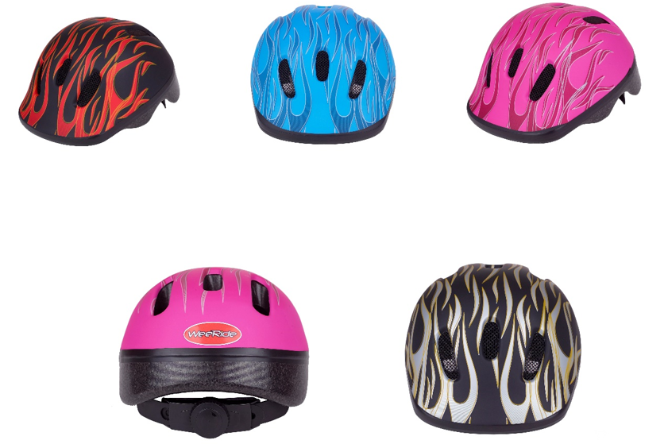

SUMMARY
At WeeRide we test our kids bike helmets to ensure we have the best range for your child.
All our baby bike helmets meet all safety standards and have exceptional design. CE - EN 1078 Approved.
Our bicycle helmets are the smallest and lightest baby bike helmet you can buy for your baby and are of exceptional quality from a European manufacturer.
The new helmets are a beautiful matt finish.
KEY SALES POINTS
Lightweight at only 190g
Smallest size available 44cm -48cm helmet so fits from 1 year old
Twist tightening technology for the snuggest fit
Washable padding
Available in pink, blue or white

BOX SIZE 27 x 16 x 21
WEIGHT 340g
AGE 6months – 3 years

WHY WOULD YOU BUY A WEERIDE INSTEAD OF THE COMPETITION
A brand you can trust will deliver a quality and safe product at a great price.
Our helmets deliver a perfect fit due to twist grip technology and are very shallow and light for child comfort.

WHO WOULD USE THIS PRODUCT?
Children from as young as 6 months, please check their head circumference meets our limits of 44-48cm.
WeeRide Cycle Accessories
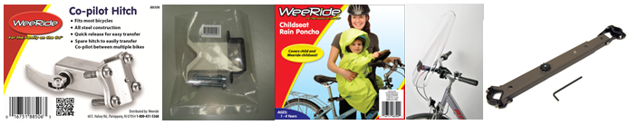
PONCHO | 98300
WINDSHIELD | 8631600001
WEERIDE MOUNTING BAR | 96064
TAG A LONG HITCHES | 88506

Pic 1 - Tagalong spare hitches and seat spare mounting bars allow you to attach your WeeRide product to another bike without having to move the fixing point. This will save a lot of time as a seat or tagalong can be moved from one bike to another in under a minute.
Pic 2 - Our new bar adaptor kit allows our seat to fit to even more bikes. When Giant released their bikes with oversized top tubes in 2013 we had an issues attaching our bar, but this adaptor kit resolves that problem.
Pic 3 – Our WeeRide poncho will protect your little one from the rain and is big enough to cover your child, their helmet and the seat
Pic 4 – the WeeRide windshield is for those children who don’t like the feel of the elements in their face when they are on a bike

Kazam Balance Bike
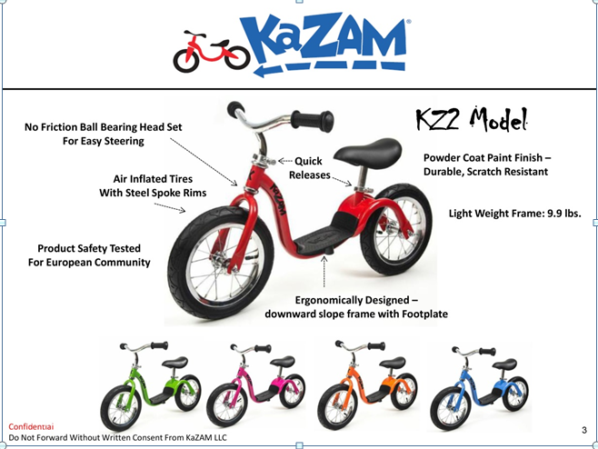
SUMMARY
KaZAM is the multi award winning, number 1 name in balance bikes in the US and is now available worldwide. They are unique due to the central footplate which allows your child to “scoot” on their push bike when confident and improve their balance skills further. KaZAM balance bikes meet all worldwide safety standards as you would expect from a US manufacturer. The attention to detail on the toddler bikes can be seen throughout and the parts used are the same as you would see on a high qualitybalance bike such as no friction ball bearing headset for easy steering, air inflated tyres with steel spokes, quick release headset and seat post etc. None of which you will see on cheaper models. These balance bikes are built for safety and longevity.
We kept the bike light, but also made it look like a bike and not a toy. The metal frame and beautiful paint job ensure your child will be proud of their new bike.
KEY SALES POINTS
- KaZAM name and guarantee
- Easy step through frame
- Very light at only 4.55kgs
- Seat height from 38cm -48cm
- New soft seat
- Quick release seatpost and headset for easy adjustment
- Powder painted for durability and scratch resistance
Awards & Recognition * Oppenheim Toy Portfolio Platinum Seal Award 2014 * Featured on ABC’s Shark Tank (Update), March 2014 * Featured on ABC’s 20/20, December 2013 * Featured on ABC’s Shark Tank, May 2013 * Tillywig Top Fun Award Winner, 2013 * Parents Magazine, “20 Best Summer Toys”, June 2011 edition Summer's Hottest Toys * Parenting Magazine, “Balance Bikes For Kids”, July 2011 edition * National Parenting Center’s (NPC) Spring 2011 Seal of Approval * Oppenheim Toy Portfolio Gold Seal Award 2010, 2009 * Creative Child Magazine 2010 Toy of The Year Award, Ride-On Toys-Balance Bike * Dr Toy Awards: 10 Best Active Products, 100 Best Children's Product s, 2010, 2009 • NBC’s Today 2010
Patents * USA * China * EU Countries
Kazaam Baby Child Toddle Balance Bike for 2, 3 , 4 years Red | KZM14SRD
Kazaam Baby Child Toddle Balance Bike for 2, 3 , 4 years Green | KZM14SGR
Kazaam Baby Child Toddle Balance Bike for 2, 3 , 4 years Pink | KZM14SPK
Kazaam Baby Child Toddle Balance Bike for 2, 3 , 4 years Blue | KZM14SBL
Kazaam Baby Child Toddle Balance Bike for 2, 3 , 4 years Orange | KZM14SOR
Trockolino Baby Bike Seat Cover


Trockolino are a German company who produce very high quality child seat covers. They have produced one that exclusively fits the WeeRide baby bike seat and we have exclusive distribution for this line.
There are 2 models (one is lockable), and 2 colours
TROCKOLINO® (based on german “trocken” = dry)
Our covers are made of thoroughly chosen waterproof fabric and come with a little bag for easy storage, which can be attached to the child seat

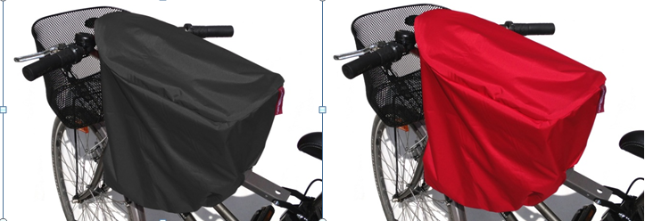
item name | product code | EAN code
TROCKOLINO WeeRide classic black | 310 | 4260241130508
TROCKOLINO WeeRide classic red | 320 | 4260241130515
TROCKOLINO WeeRide with eyelet black | 312 | 4260241130522
TROCKOLINO WeeRide with eyelet red | 322 | 4260241130539

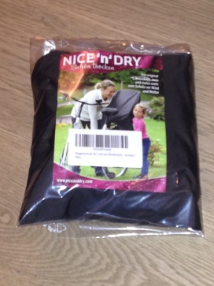

OTHER OFFERS FROM KAZAM…
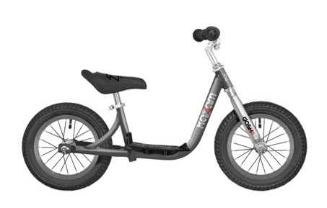12 INCH DASH £99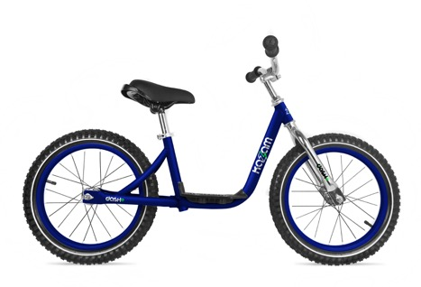16 INCH DASH £109
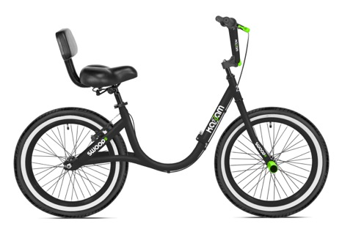20 INCH SWOOP £129
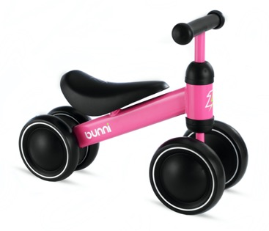BUNNI £49
Please let us know if you are interested in any of these products and we can provide more information.

